DBMS Mini Project

Project Title: Weather Report

Team Members:

1.Amrit Kalsi - Reg no: RA1811003010439

2.Akshansh Gupta – Reg no: RA1811003010469

Abstract

Our Project Title is Weather Report so given by the name we have made a database of different days and the weather it is on that day with temperature and humidity of that day. For the backend tool we have used SQL and for the frontend tool we have used HTML, CSS and PHP. We will also take a user input beside the table represented on a webpage to run a search algorithm among the data set and fetch that value that is requested by the user.

List of Modules:

Front-end tools:

1. HTML

2. PHP

1. CSS

Back-end tools:

1. SQL

Modules Explanation

**SQL**: In this module first we created a new database called ‘Weather_Report’. Then we connect it to the database using the command “connect Weather_Report”. Then the database is connected. Then we will write the code to create a table and feed the values under the columns Day_Number, Outlook, Temp and Humidity. We have interested values of 2 weeks i.e.; 14 days. So there are 14 entries and we display it using the SELECT command

**HTML**: As this is a front-end tool, we use to represent the table on a web-page. In the html code we define the heading, the sub-headings and the content which we will fetch from the SQL database which is working as a back-end tool.

We are also taking a input from the user that is : “Day Number”. When the submit button is clicked page is loaded and that column is fetched which is requested by the user. It is displayed on a new php page.

**PHP**: PHP is an HTML-embedded server-side scripting language. Much of its syntax is borrowed from C, Java and Perl with a couple of unique PHP-specific features thrown in. The goal of the language is to allow web developers to write dynamically generated pages quickly. So, PHP connects the SQL database and the HTML page.

**CSS**: CSS is the language for describing the presentation of Web pages, including colors, layout, and fonts. It allows one to adapt the presentation to different types of devices, such as large screens, small screens, or printers. CSS is independent of HTML and can be used with any XML-based markup language. CSS is used for the design part of the web-page and to make it more interactive to the user. A few colors here and there always brighten ups the mood.

**Screenshots**:

* **Snip of Table created in the SQL Console with 14 entries**.

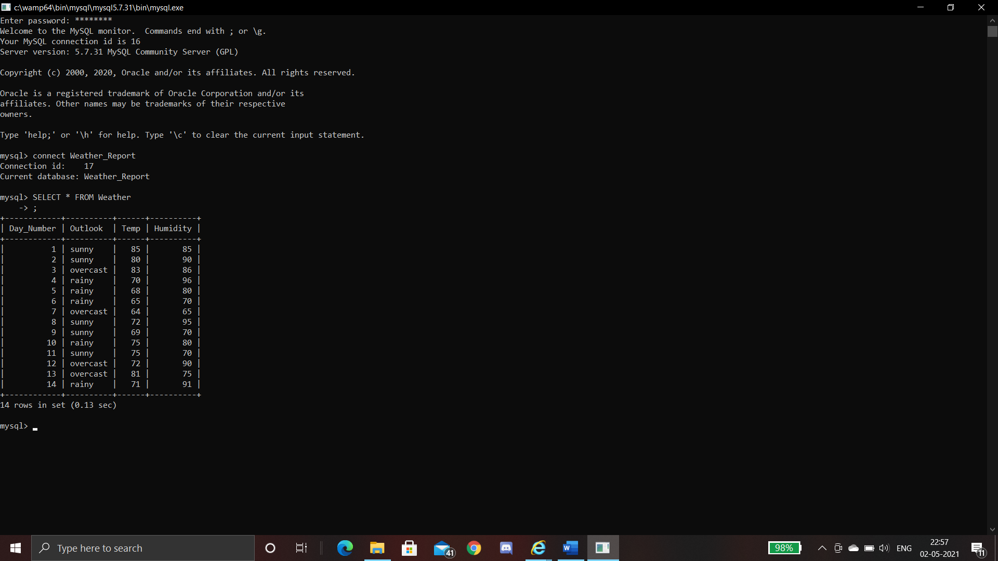

* **Snip of taking a user input from the user for eg: 6 (this is a html page)**

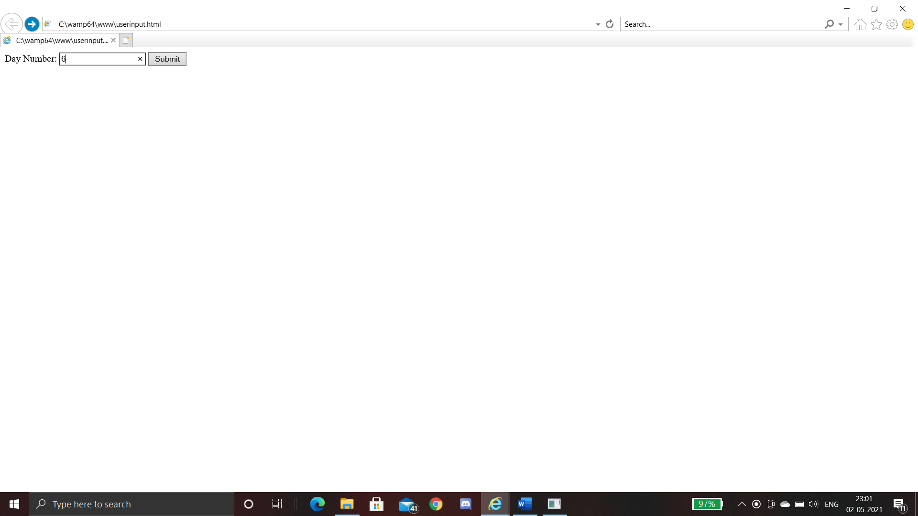

* **The Result is shown below, the 6th column is fetched from the SQL database and shown on a new page (php page)**

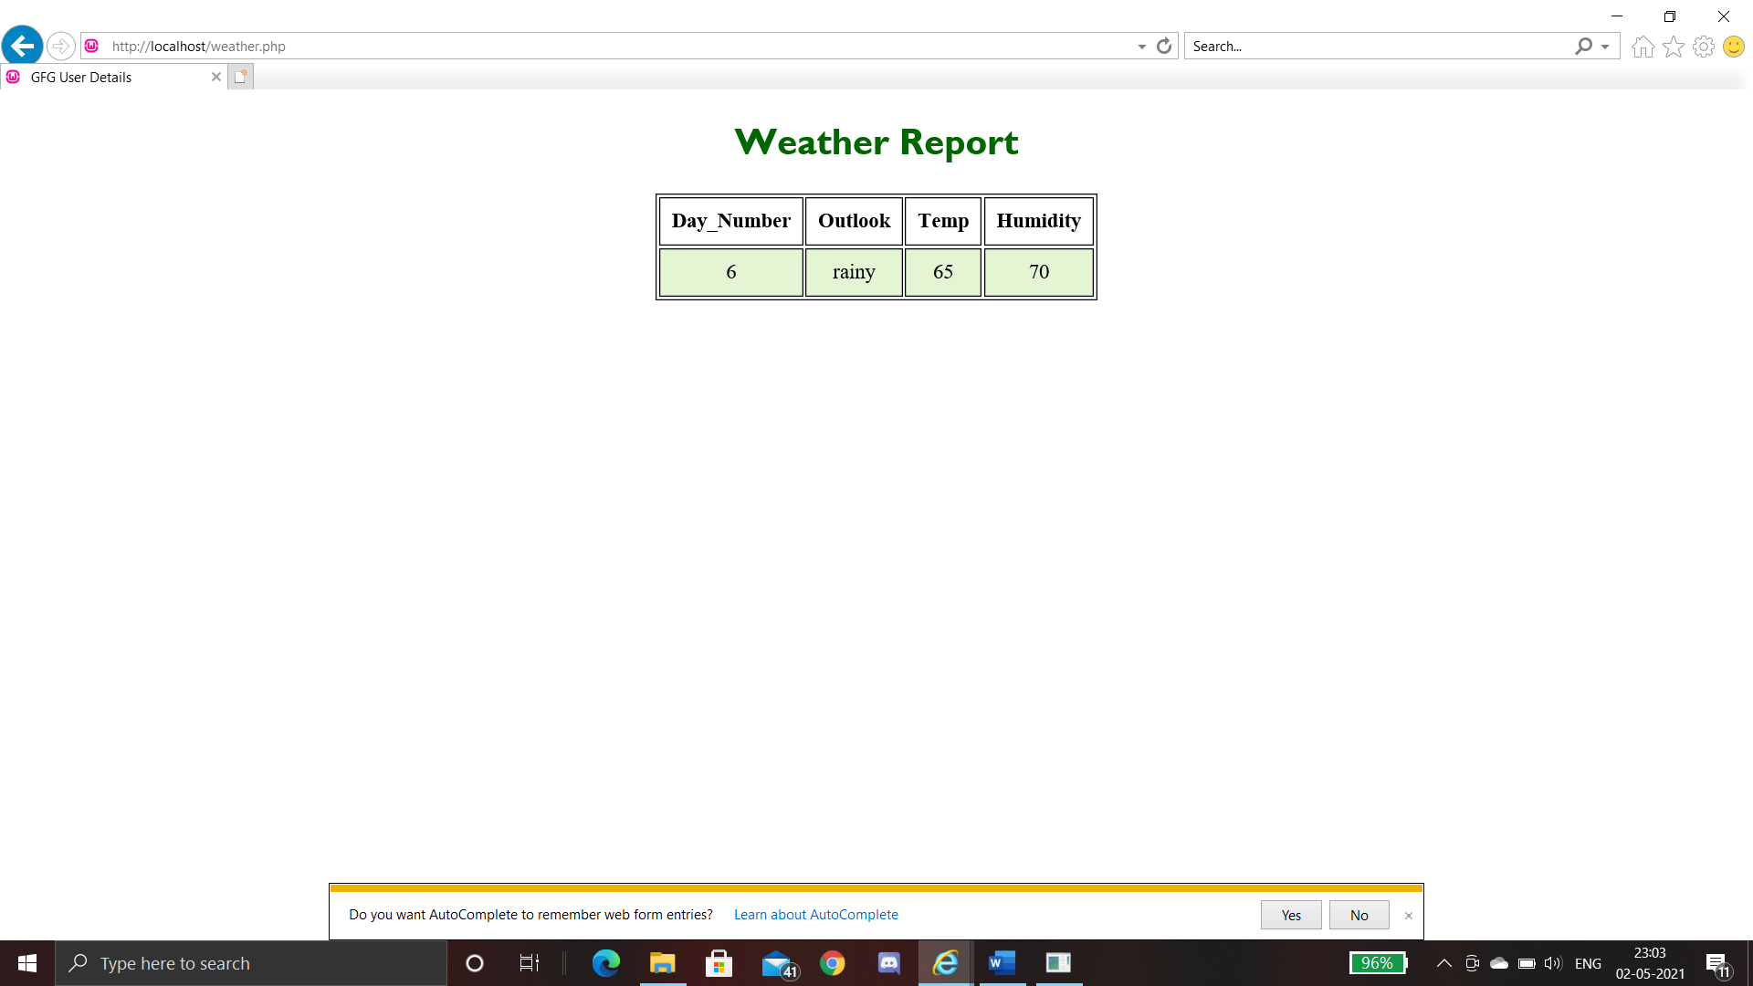

* **Snip of whole table, this is the whole table (php file) so as you can see the CSS,HTML and PHP is ruled for representation.**

